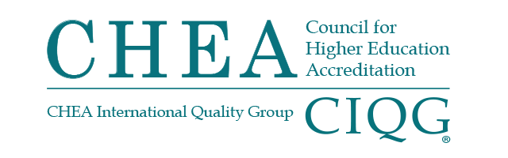

BOARD OF DIRECTORS AND ANNUAL MEETING
MONDAY, MAY 3, 2021
WASHINGTON, DC
VIRTUAL MEETING
4:00 p.m. – 5:15 p.m.

Summary of Major Actions and Discussion

(These are not official minutes of the CHEA Board of Directors.)

Chair Orlando Taylor called the meeting to order at 4:02 p.m.
TREASURER’S REPORT
The board of directors:
- Received the FY21 third quarter financial report.
- Received an update on FY21 institutional membership.
- Received an update from the Reserve, Investment and Audit Committee
GOVERNMENT AFFAIRS REPORT
Senior Vice President Jan Friis reported that the U.S. Senate confirmed Miguel Cardona as U.S. Secretary of Education, and the Senate Health, Education, Labor, and Pensions (HELP) Committee approved the nominations of Cindy Marten to be Deputy Secretary of Education and James Kvaal to be Under Secretary of Education. Their nominations have been sent to the full Senate and are awaiting confirmation. President Biden has several additional nominations he can make, and until those nominations are confirmed it will take longer for the USDE to do its policy work.
Friis reported that Senator Patty Murray (D-WA) will chair the HELP Committee and Richard Burr (R-NC) will be the Committee’s Ranking Member. Twenty-two percent of the members of the Committee did not serve on the Committee in the last Congress. Friis explained that Rep. Bobby Scott (D-VA) will remain Chair of the House Education and Labor Committee, with Rep. Virginia Foxx (R-NC) as Ranking Member. The Chair of the Subcommittee on Higher Education and Workforce Investment is Rep. Frederica Wilson (D-FL), and the Ranking Member is Gregory Murphy (R-NC). Both are new to these assignments. Thirty percent of the members of the Committee are freshman. Thirty-nine percent of the Committee did not serve on the Committee in the last Congress.
Friis also discussed the Covid-19 related bill proposed by the administration. There is money in these bills for higher education. He also reported that the National Advisory Committee on Institutional Quality and Integrity recommended that the Accrediting Council for Independent Colleges and Schools be denied continued recognition and that CHEA continues its work with Washington associations.
PRESIDENT’S UPDATE
At the Working Session, President Jackson-Hammond reported on the CHEA Fellow’s program and noted that the first fellow is expected to join CHEA in late summer. She updated the board on the 2021 Summer Roundtable scheduled for late June 2020. The event will be held virtually and the program has been extended to include university and college boards of directors, government affairs officers, provosts, deans and accreditation officers.

ELECTION OF NEW MEMBERS OF THE CHEA BOARD OF DIRECTORS
The board of directors elected the following individuals to serve on the CHEA board for 2020−2023:
- Robert Clark, President and CEO, Husson University*
- Gena Glickman, President Emeritus, Manchester Community College*
- Lester Newman, President, Jarvis Christian College*
- Colette Pierce Burnett, President and CEO, Huston-Tillotson University
- David A. Schmidt, President, The American University in Dubai
- Cynthia Spiers, President, Rhodes State College
- Lori Williams, President and CEO, National Council for State Authorization Reciprocity Agreements
* Incumbent elected to serve a second three-year term.
ELECTION OF 2021-2021 BOARD OFFICERS
The board of directors elected the following officers and members of the board executive committee:
- Chair: Gena Glickman, President Emerita, Manchester Community College
- Vice Chair: Dottie King, President, Saint Mary-of-the-Woods College
- Secretary: Antoine Garibaldi, President, University of Detroit Mercy
- Treasurer: Robert Clark, President and CEO, Husson University
- Member-at-Large: Lester Newman, President, Jarvis Christian College
- Immediate Past Chair: Orlando Taylor, Distinguished Senior Advisor to the President, Fielding Graduate University
2021-2021 ORGANIZATIONAL GOALS AND BUDGET
President Jackson-Hamond presented and the board approved the 2021-2022 organizational goals and budget that address CHEA’s major function areas of government affairs, recognition, membership services, international quality assurance, research and policy analysis and Fellows program.

The next meeting of the CHEA Board of Directors will take place
October 4, 2021 and will be virtual.

