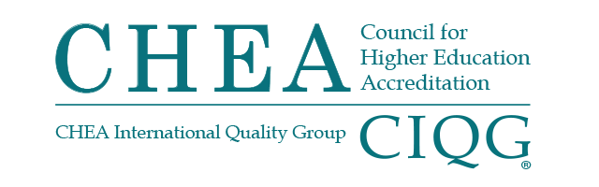

BOARD OF DIRECTORS MEETING
Monday, January 24, 2022
Hybrid Meeting
1:00 p.m. – 2:15 p.m.

Summary of Major Actions and Discussion

(These are not official minutes of the CHEA Board of Directors.)

Vice Chair King called the meeting to order at 1:02 p.m.

TREASURER’S REPORT
The board of directors:
- Received the FY22 first and second quarter financial report.
- Received an update on FY22 institutional membership.
CHAIR’S REPORT
The board of directors, upon recommendation from the Committee on Recognition acted to award the maximum term of recognition (seven years) to the Accreditation Commission for Audiology Education (ACAE), Accreditation Commission for Programs in Hospitality Management (ACPHA), American Veterinary Medical Association Council on Education (AVMA-COE), Association for Biblical Higher Education Commission on Accreditation (ABHE), Commission on Accreditation for Health Informatics and Information Management Education (CAHIIM), Commission on Accreditation for Respiratory Care (COARC) and Commission on Accreditation of the Association of Theological Schools (COA-ATS) with an interim report due at the midpoint of the recognition term. Further, the board of directors acted to defer a recognition decision for one year for the International Fire Service Accreditation Congress-Degree Assembly (IFSAC-DA).

Vice Chair King reported that, during the Working Session, the board received a report from the Reserve, Investment and Audit Committee. The board was informed of the finalization of updated Board Bylaws to be signed in February 2022. There was also a Board Task Team engagement update.
President Jackson-Hammond introduced three new staff members. She informed the board that the new Recognition Policy went into effect on January 1, 2022 and notified the board of a new marketing initiative being undertaken in 2022.
Government Affairs Report
Senior Vice President Jan Friis reported that this has been a challenging time in Congress. With the debates on the Build Back Better bill, the Voting Rights Act and the changing of the filibuster rule, the Senate has not had time for anything else. February will be consumed with debates on funding levels for the government for the balance of the year. There are some discussions, but no written proposals, in the House of Representative about accreditors evaluating tuition costs versus the income for graduates from programs.

Friis reported that the Department of Education is moving forward on two negotiated rulemakings which are likely to have proposed rules available for public comment this summer. There is some concern that the Department will add another negotiated rulemaking concerning program integrity and accreditation, but it is not yet announced, and the Department is fully engaged now.
President’s Update
2022 Annual Conference
President Cynthia Jackson-Hammond provided information about the 2022 Annual Conference to be held as a hybrid meeting for the first time.
The meeting was adjourned at 1:16 p.m.

The next meeting of the CHEA Board of Directors will take place
May 2, 2022 in Washington, DC.

