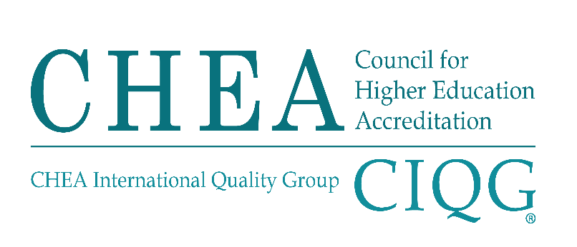

2019 RECOGNITION POLICY AND PROCEDURES

STEPS IN RECOGNITION REVIEW

SUMMARY

The sequence of the CHEA recognition review will generally be as follows:
- Before pursuing a recognition review, the accrediting organization consults with CHEA staff regarding the recognition policy, process and CHEA expectations (Paragraph 20, Recognition Policy and Procedures).
- If appropriate, CHEA staff forwards the CHEA Application Form for Recognition to the accrediting organization.
- To initiate the formal process for recognition, the chief executive officer of a free-standing accrediting organization or head of an accreditation unit in a larger organization completes, signs and submits the CHEA Application Form for Recognition, including the $10,000 non-refundable application fee. CHEA will inform the Committee on Recognition and the public that the accrediting organization is seeking recognition (Paragraph 21, Recognition Policy and Procedures).
- The accrediting organization completes and submits an Application Narrative in accordance with the CHEA Guidelines for Preparation of an Application Narrative (Paragraph 22, Recognition Policy and Procedures). If requested by the accrediting organization, CHEA staff will provide consultation.
- CHEA and the accrediting organization mutually agree on the visitor(s), including experts as needed, and the schedule for an observation visit to be carried out during the recognition review. Observation visit reports are due in the CHEA office and forwarded to the accrediting organization for comment. All fees and costs for observation visits are borne by the accrediting organization (Paragraphs 23-24, Recognition Policy and Procedures).
- CHEA issues a public notice to provide an opportunity for third-party comment, if any, on the accrediting organization’s application for recognition. The accrediting organization is required to publicize its pursuit of CHEA recognition using the Public Statement of CHEA Recognition Review (Paragraph 25, Recognition Policy and Procedures).
- Third party comment, if any, is due in the CHEA office by the announced deadline and forwarded for comment to the accrediting organization (Paragraph 26, Recognition Policy and Procedures).
- The accrediting organization’s responses to the observation visit reports and third-party comment and the final recognition self-evaluation are due at the CHEA office by the announced deadline. The accrediting organization’s responses and recognition self-evaluation are forwarded to Committee.

- The accrediting organization makes a public presentation to the Committee. If necessary, observation visitors or experts may participate (Paragraph 27, Recognition Policy and Procedures).
- The Committee completes its preliminary analysis, including board consultation (Paragraph 28, Recognition Policy and Procedures).
- The Committee considers the board comments and provides its recommendation on recognition to the Board of Directors (Paragraph 29, Recognition Policy and Procedures).
- The Committee will notify the accrediting organization of its recommendation within thirty (30) calendar days following the Committee meeting. The accrediting organization’s response, if any, is due to the Committee by the announced deadline (Paragraphs 30-31, Recognition Policy and Procedures).
- The Board of Directors considers the Committee recommendation (Paragraph 32, Recognition Policy and Procedures).
- The Board of Directors will notify the accrediting organization within thirty (30) calendar days after taking action (Paragraph 34, Recognition Policy and Procedures).
- CHEA will publish the Board actions and a summary of the reason(s) for decisions to recognize, defer, deny or withdraw recognition (Paragraph 39, Recognition Policy and Procedures).
In developing the schedule, CHEA staff will make reasonable accommodations for the accrediting organization’s internal review procedures pertinent to the recognition process.

