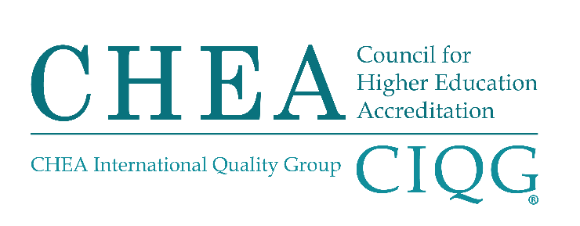

CHEA CHANGE OF SCOPE REQUEST FORM

Please complete this Change of Scope Request Form in its entirety before submitting it to CHEA for review by the Committee on Recognition.

- Introduction

- Name of accrediting organization (include preferred acronym):
- Address:
- Website:
- Name of chief executive or head of accreditation unit and title
- Month and year of most recent CHEA recognition:

- Provide the organization’s current CHEA-recognized scope of accreditation as last approved by CHEA.
Current CHEA Scope Statement (including year approved): [Text box is expandable]

- Provide the organization’s proposed CHEA-recognized scope of accreditation.
Proposed CHEA Scope Statement (highlight or track proposed changes as appropriate): [Text box is expandable]

CHEA Recognized Scope of Accreditation (Recognition Policy, Paragraphs 7 and 8): CHEA-RECOGNIZED SCOPE OF ACCREDITATION

Paragraph 7. CHEA-RECOGNIZED SCOPE OF ACCREDITATION. CHEA recognizes accrediting organizations for work in judging the quality of U.S. institutions and programs and, where permitted under this policy, other institutions and programs at the associate degree level or above.

The accrediting organization submits evidence of its capacity and competence to carry out accreditation activities identified in the scope statement.

The accrediting organization submits a clear statement of its proposed scope of recognition, which will be used to inform the public of the accreditation activities for which the accrediting organization holds recognition. The scope statement includes the following information about the accreditation activities for which recognition is sought: (1) types of institutions or programs; (2) degree levels; (3) geographic boundaries of accreditation activity, including specification of United States and international locations; and (4) degree areas or professional fields of study.

Recognition is available only if a majority of institutions or programs the organization accredits grant degrees at the associate degree level or above. The CHEA-recognized scope of accreditation also may or may not include additional offerings, such as internships, clinical training and post-doctoral work.

However, such offerings are not counted when determining whether the accrediting organization meets the degree-granting requirement.

Separate from the scope statement, the accrediting organization identifies any accreditation activities it conducts for which it is not seeking recognition. These activities are not part of the CHEA recognized scope of accreditation.

Paragraph 8. CHANGES IN THE CHEA-RECOGNIZED SCOPE OF ACCREDITATION. Proposed changes in the CHEA-recognized scope of accreditation are considered by the Committee on Recognition (Committee) during or outside a regular recognition review. Changes in CHEA-recognized scope of accreditation include but are not limited to: (1) change in the type(s) of institutions and programs to be accredited; (2) addition or removal of a degree level; (3) change of geographical boundaries of accreditation activity, such as an expansion to include activity outside the United States; and (4) addition or removal of a degree area or professional field of study.

To be considered for a change in the CHEA-recognized scope of accreditation, the recognized accrediting organization submits:

- Its current statement of CHEA-recognized scope of accreditation;
- A clear statement of the proposed change in the CHEA-recognized scope of accreditation;
- The reasons for the proposed change, including evidence that the accrediting organization’s decision-making body has authorized the change;
- Evidence of the accrediting organization’s capacity and competence to carry out accreditation reviews under the new proposed scope, including evidence from the results of pilot reviews;
- A timetable for implementation of the new CHEA-recognized scope of accreditation, including impact on currently enrolled students affected by the change; and
- Evidence of consultation with appropriate constituencies.

The decision of the Committee with respect to a requested change in CHEA-recognized scope of accreditation will be final unless the Committee refers the matter to the Board of Directors (Board). The Board in its discretion also may act on an accrediting organization’s scope of accreditation in the recognition review process or incident to a requested change of scope.

If a recognized accrediting organization alters its CHEA-recognized scope of accreditation in non-substantive ways, e.g., editorial revisions, it promptly notifies CHEA staff and includes a brief description of what led the accrediting organization to make the alterations. CHEA will modify its documents that include the CHEA-recognized scope of accreditation.

- Provide the organization’s current CHEA-recognized scope of accreditation as last approved by CHEA (provided on p. 1).

- Provide the organization’s proposed CHEA-recognized scope of accreditation (provided on p. 1).

C. The reasons for the proposed change, including evidence that the accrediting organization’s decision-making body has authorized the change.
[Text box is expandable, include links as appropriate]

D. Evidence of the accrediting organization’s capacity and competence to carry out accreditation reviews under the new proposed scope, including evidence from the results of pilot reviews.
[Text box is expandable, include links as appropriate]

E. A timetable for implementation of the new CHEA-recognized scope of accreditation, including impact on currently enrolled students affected by the change; and
[Text box is expandable, include links as appropriate]

F. Evidence of consultation with appropriate constituencies.
[Text box is expandable, include links as appropriate]

The decision of the Committee with respect to a requested change in CHEA-recognized scope of accreditation will be final unless the Committee refers the matter to the Board of Directors (Board). The Board in its discretion also may act on an accrediting organization’s scope of accreditation in the recognition review process or incident to a requested change of scope.

If a recognized accrediting organization alters its CHEA-recognized scope of accreditation in non-substantive ways, e.g., editorial revisions, it promptly notifies CHEA staff and includes a brief description of what led the accrediting organization to make the alterations. CHEA will modify its documents that include the CHEA-recognized scope of accreditation.

Submit all materials to recognition@chea.org. If questions, call CHEA at 202-372-9254.

