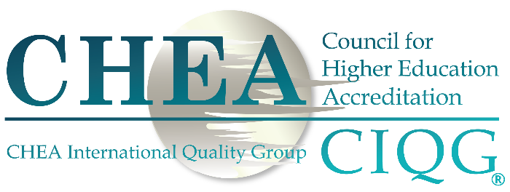
2019 CIQG QUALITY AWARD

Application

Applications that do not conform to format and length will not be considered by the Panel of Experts. Please provide a succinct description of how each principle is met; do not rely solely on a review of links by the Panel. Applications are to be submitted in English.

Provider Name

Section 1: Contact Information of Person Submitting Application
Name
Title
Provider
Street Address
City, State, Country, Zip/Pin
Phone
Email
Signature (electronic accepted)

Section 2: Provider Endorsement
Chief Executive Officer or Chief Academic Officer
Name
Title
Provider
Phone
Email
Signature (electronic accepted)

Section 3: Provider Overview
Affiliation or Control
(Public or Private)
Highest Credential Offered
Student Enrollment (HC)
Brief Description of Mission
Competent Authority and Date of Last Review

Section 4: Application Summary
Please provide a summary of the award application that may be used in CHEA/CIQG publications and in award presentations. Please do not exceed 100 words. The text box may be increased in size as necessary.

Section 5: Award Requirements

PRINCIPLE 1

Quality and higher education providers: Assuring and achieving quality in higher education is the primary responsibility of higher education providers and their staff.
Required Information
- Description of how the provider addresses its primary responsibility. This includes:
  - How this responsibility is embedded in a provider’s culture
  - Support from provider leadership, including faculty and students
  - How the responsibility is carried out, including initiatives or programs that the provider has put in place]
  - Testimonials from external stakeholders (e.g., employers, civil society organizations or groups, receiving providers)
Response is to be limited to one-to-two pages. The following text box may be increased in size as necessary.

Section 5: Award Requirements

PRINCIPLE 2

Quality and students: The education provided to students must always be of high quality whatever the learning outcomes pursued.
Required Information
- Evidence that high-quality student learning outcomes are established and at a postsecondary or tertiary education level
- Evidence that the claim of “high-quality” is justified
- Evidence of learning outcomes that may include information about:
  - Completion or graduation
  - Success with licensure or other entry-to-profession examinations
  - Successful transfer of credit
  - Entry to graduate school
  - Job placement
- Description of basis of evidence for the learning outcomes, e.g.,
  - Faculty-designed comprehensive or capstone examinations and assignments
  - Portfolios of student work over time
  - Samples of representative student work
  - Other bases as provided
Response is to be limited to one-to-two pages. The following text box may be increased in size as necessary.

Section 5: Award Requirements

PRINCIPLE 3

Quality and society: The quality of higher education provision is judged by how well it meets the needs of society, engenders public confidence and sustains public trust.
Required Information
- Major, current societal needs are identified, whether local, national or regional
- Evidence that the needs are met, including documentation of confidence and trust
- Evidence can include:
  - Examples of provider initiatives established to meet societal needs and success with the initiatives
  - Surveys of students that document that at least some societal needs are met or being met
  - Testimonials from external stakeholders (e.g., employers, civil society organizations or groups, receiving providers)
Response is to be limited to one-to-two pages. The following text box may be increased in size as necessary.

Section 5: Award Requirements

PRINCIPLE 4

Quality and government: Governments have a role in encouraging and supporting quality higher education.
Required Information
  - What counts as government encouragement and support
  - Evidence that the encouragement and support are sustained
  - Examples of trust between government and provider
NB: Providers cannot be fully responsible for the level of government encouragement and support that is provided. This Principle calls for a description of the role of government and does not involve the Award Panel in judging this level.
Response is to be limited to one-to-two pages. The following text box may be increased in size as necessary.

Section 5: Award Requirements

PRINCIPLE 5

Quality and accountability: It is the responsibility of higher education providers and quality assurance and accreditation bodies to sustain a strong commitment to accountability and provide regular evidence of quality.
Required Information
- Evidence that accountability measures have been developed and implemented by both the provider and quality assurance or accreditation body
- Evidence that these measures are met
- Evidence that the provider’s information about quality is made available regularly
NB: Although the Award Panel is seeking a description of what a quality assurance or accreditation body does about accountability, the provider will be judged only on the provider’s efforts with regard to accountability.
Response is to be limited to one-to-two pages. The following text box may be increased in size as necessary.

Section 5: Award Requirements

PRINCIPLE 6

Quality and the role of quality assurance and accreditation bodies: Quality assurance and accreditation bodies, working with higher education providers and their leadership, staff and students, are responsible for the implementation of processes, tools, benchmarks and measures of learning outcomes that help to create a shared understanding of quality.
NB: The provider is asked to provide only a brief description of the quality assurance or accreditation body that reviews the provider and its expectations with regard to learning outcomes. To the extent that quality and accountability expectations (Principle 5) overlap, please refer the reader to Principle 5. The provider will not be judged on what the quality assurance or accreditation body does or does not do.
Response is to be limited to one-to-two pages. The following text box may be increased in size as necessary.

Section 5: Award Requirements

PRINCIPLE 7

Quality and change: Quality higher education needs to be flexible, creative and innovative; developing and evolving to meet students’ needs, to justify the confidence of society and to maintain diversity
Required Information
- Documentation of the provider’s commitment to innovation in its education programs and services
- Evidence that these commitments have been implemented and the effectiveness of the various efforts
- Examples of successful efforts at innovation
- Testimonials from external stakeholders (e.g., employers, civil society organizations or groups, receiving providers)
Response is to be limited to one-to-two pages. The following text box may be increased in size as necessary.

